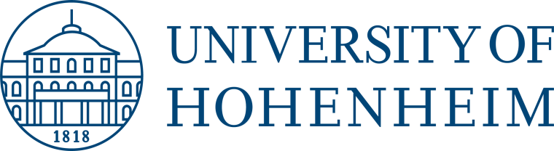

APPLICATION FORM

Humboldt reloaded interdisciplinary

Summer School 2018
’’Health Sciences”
University of Hohenheim
September, 12 – September 21, 2018
Please complete digital and send this form including a certificate for study to:

Nicole Henninger
University of Hohenheim, Germany
hrsummerschool@uni-hohenheim.de
Application deadline: May 18, 2018

Personal data
Family name:

First name(s): |  |  | Male: |  | Female:
Date of birth:  (date/month/year) |  |  | Nationality:

Current address
Street and No.:

Mobilephone No.: | E-mail:
Postal code and city: | Country:

Academic profile
Study program/ specialty: | University:
 | Faculty:

Semester:

Language proficiency in English:

Indicate level: □ A:Basic □ B:Independent □ C:Proficient

Motivation for participation in the interdisciplinary Summer School.
Relevant prior studies/ academic background:

Signature of applicant

I wish to apply for the Humboldt reloaded interdisciplinary Summer School 2017 “Health Sciences” at the University of Hohenheim. I hereby confirm that the above information is correct.

I have been informed that I have to ensure adequate health insurance during the duration of the programme.

Date: |  | Signature:

For students from abroad

Alternative/Parents address
Street and No.:

Postal code and city: | Country:
Telephone No.: | Fax No.: | E-mail:

Contact person in case of emergency
Name: | Relationship:
Street and No.:

Postal code and city: | Country:
Telephone No. (Private/ Work): | Fax No.: | E-mail:

